AFRICAN CENTRE OF EXCELLENCE IN DATA SCIENCE (ACE-DS)
ADVANCED DATABASE PROJECT-BASED CAT 2
Module Code: DSM6235
Topic: DIGITAL HEALTH INSURANCE & CLAIMS
Student Name: KALIKUMUTIMA David
Stud.ID: 224020870

Task 1: Distributed Schema
-----------------------------------------------------------------------
Description & Key Deliverables: Split your database into two logical nodes (e.g.,
BranchDB_A, BranchDB_B) using horizontal or vertical fragmentation. Submit an ER diagram and SQL scripts that create both schemas.
The existing Health Insuarence database is which currently has a central "InsuranceCompany" table and multiple dependent tables like: Plans, PolicyHolder, Hospital, Service, Claim, Assessor and Payment. If I classify insurance companies as Public or Private, I can horizontally partition all dependent table’s data by that category —meaning: 1) Node A (Public node): as the database that keeps all data related to public or government insurance companies.

/*Steps for distribution:*/
------------------------------
--step 1: Enable extensions in main database and Create separate databases
--Enable extensions
CREATE EXTENSION IF NOT EXISTS dblink; -- DB link for DB inter connection and access
CREATE EXTENSION IF NOT EXISTS postgres_fdw; -- Enable FDW (foreign data wrapper) extension to distribute the data across databases.
-- Create separate databases
CREATE DATABASE public_insurance;
CREATE DATABASE private_insurance;

--step 2: Set Up Private Insurance and public Insurance Database Structure
--Connect to private_insurance database and create tables:
(Create all tables with same structure)

--step3: Set Up Public Insurance and public Insurance Database Structure
--Connect to public_insurance database and create tables:
(Create all tables with same structure)

Task 8: Three-Tier Client–Server Architecture Design
---------------------------------------------------------------------------
WHAT TO DO: Draw and explain a three-tier architecture for your project (Presentation, Application, Database). Show data flow and interaction with database links.
3-tier application architecture
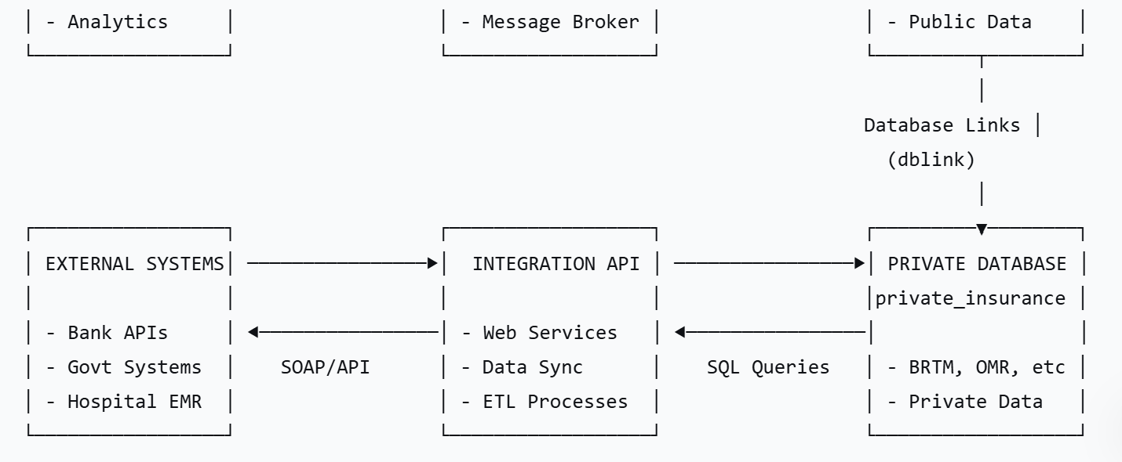
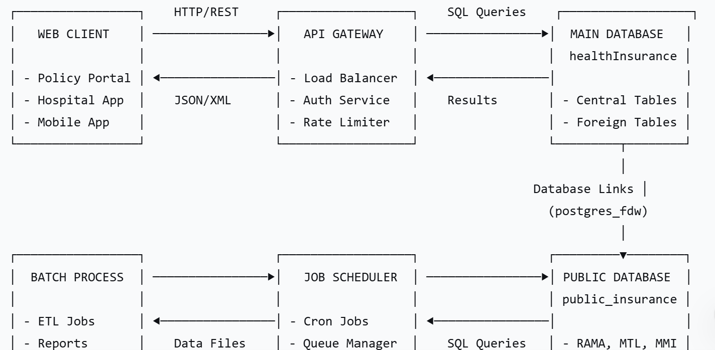

In our project, we have distributed databases (public_insurance and private_insurance) and the main healthInsurance database. We also have database links (using postgres_fdw and dblink) to connect between the main database and the distributed databases.
the architecture is as follow:
Presentation Tier:
- This is the user interface (web or mobile) that interacts with the application tier.
- It sends requests (like viewing policy holders, claims, etc.) and receives responses.
Application Tier:
- This is the server-side application (using a framework like Node.js, Spring, etc.) that handles business logic.
- It communicates with the database tier to fetch or update data.
- In our case, the application tier might need to query data from multiple databases (public_insurance and private_insurance) using database links.
Database Tier:
- We have three PostgreSQL databases: healthInsurance (main database), public_insurance, private_insurance.
- The healthInsurance database has foreign tables (via postgres_fdw) and database links (via dblink) to the public_insurance and private_insurance databases.
Data Flow:
- The presentation tier sends a request to the application tier (e.g., get all claims for a given policy holder).
- The application tier determines which database(s) to query. Since the data is distributed, it might need to query the main healthInsurance database and then use the foreign tables or database links to get data from the public_insurance and private_insurance databases.
- The application tier sends SQL queries to the healthInsurance database. The healthInsurance database then uses the foreign tables (postgres_fdw) or dblink to pull data from the public_insurance and private_insurance databases.
- The healthInsurance database returns the combined result to the application tier.
- The application tier processes the data (if needed) and sends the response to the presentation tier.

Alternatively, the application tier might directly connect to the public_insurance and private_insurance databases, but in our setup, we are using the main healthInsurance database as a gateway to the distributed databases.
However, note that in the three-tier architecture, the application tier typically connects directly to the database(s). But in our case, we have set up database links in the healthInsurance database to access the other two databases. So, the application tier only needs to connect to the healthInsurance database, and the healthInsurance database will handle the cross-database queries.

How the database links are used:
In the healthInsurance database, we have:
- Foreign tables (via postgres_fdw) that map to tables in public_insurance and private_insurance.
- Alternatively, we can use dblink to run queries on the remote databases.
The application tier only connects to the healthInsurance database. When it runs a query that involves data from the public_insurance or private_insurance databases, the healthInsurance database uses the foreign tables or dblink to get the data.
Example data flow for a query:
- Application tier sends a query to healthInsurance database to get all claims (from both public and private).
- healthInsurance database executes a query that uses:
SELECT ... FROM public_insurance_links.claim
UNION ALL
SELECT ... FROM private_insurance_links.claim

- The foreign tables (public_insurance_links.claim and private_insurance_links.claim) are linked to the claim table in the public_insurance and private_insurance databases, respectively.
- The healthInsurance database sends queries to the public_insurance and private_insurance databases to get the data.
- The healthInsurance database combines the results and returns to the application tier.
- 6. The application tier then sends the response to the presentation tier.
- This architecture allows the application tier to be unaware of the distribution of data, as the healthInsurance database handles the cross-database queries.
- However, note that the application tier must be designed to handle the possibility of slow cross-database queries and potential network issues.
- Let's write a detailed explanation of the three-tier architecture for the health insurance project.
- I'll design and explain a comprehensive three-tier architecture for the Health Insurance Management System, showing data flow and database link interactions.
- Three-Tier Architecture Diagram

